NIHVA SALES QUOTATION – SQT.21.22.XXXX
Project – Vrindavan, Mumbai
Product – Sliding & Stacking Deck for/ Swimming Pool

To,
Project head - Vrindavan,
RIL,
Mumbai
Date – 18/05/2021
Thank you for your opportunity and trust shown on “NIHVA” your preferred partner for innovative solutions. This has reference to your above-mentioned requirement, please find below our Solutions.
Sliding & Stacking Deck for Swimming Pool
Operational Technique
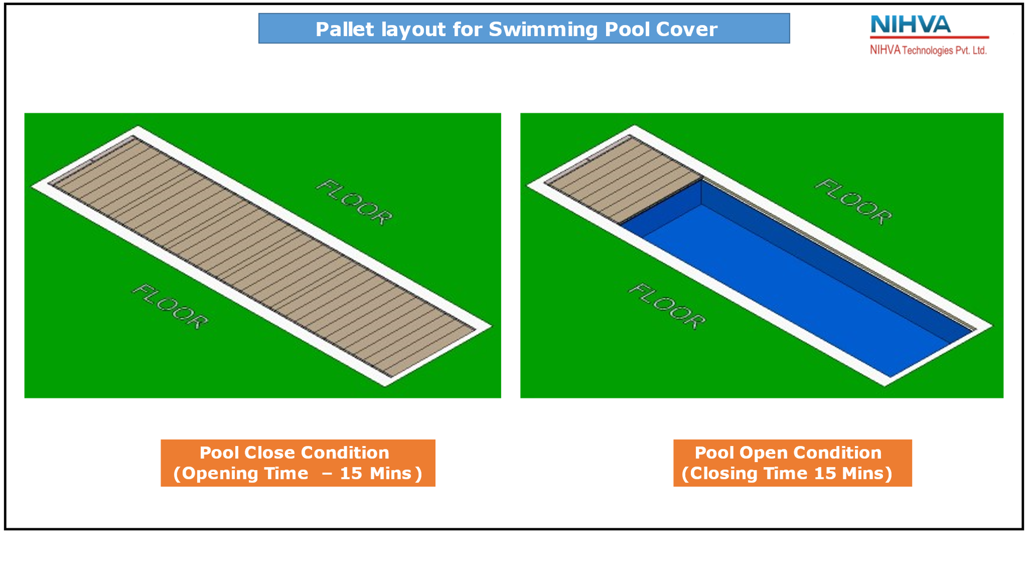
The whole framework is made of SS 316 grade. The pool and pit are covered by SS 316 structure which is divided in 6 pallets. These pallets are going to sliding with the help of induction motor and gearbox toward the pit. One by one they will get stacked in the pit and pit assembly will move vertically down each time pallet enters. The system does not depend on cables, hydraulic, pneumatic etc. It only works on electrical system with all logic connected through control panel.

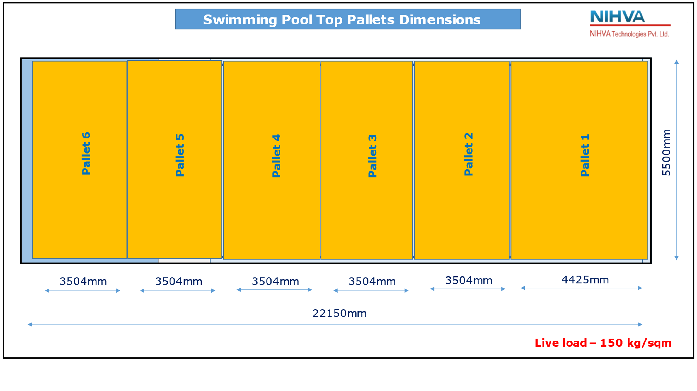

Technical Specifications with content analysis

SR NO | DESCRIPTION | QTY
MANUFACTURING EQUIPMENTS
1 | NO OF SS 316 FABRICATED PALLETS | 6
2 | LIFTER TOP SS 316 FABRICATED FRAME | 1
3 | LIFTER BOTTOM SS 316 FABRICATED FRAME | 1
4 | PALLET END STOPPER SS 316 FABRICATED FRAME | 1
5 | POWER ROLLER SS 316 FABRICATED FRAME | 1
6 | LIFTER TOP FRAME GUIDE ROD ASSLY | 4
7 | POWER ROLLER ASSLY,ROLLER OD Ø150mm | 2
8 | TOTAL PALLETS SIDE NYLON GUIDE ROLLERS | 72
9 | TOTAL PALLETS BOTTOM TRAVLING NYLON ROLLERS | 72
STANDARD BOP EQUIPMENTS
1 | PLUMMER BLOCK BEARING ID 25 | 30
2 | SINGLE RAW BALL BEARING ID 35 | 4
3 | SINGLE RAW BALL BEARING ID 10 | 144
4 | BALL PLUNGERS M10 | 48
5 | WORM TYPE SCREW JACK-10 TON CAPACITY | 4

MOTOR & GEARBOX EQUIPMENTS
1 | AC 3 PHASE INDUCTION MOTOR 3.7 KW WITH BREAK,  4 POLES, 1400RPM | 2
2 | INLINE HELICAL GEARBOX (RATIO 1:40) | 1
3 | INLINE HELICAL GEARBOX (RATIO 1:185) | 1
4 | HEAVY DUTY BEVEL BOX | 5
SENSORS & CONTROL EQUIPMENTS
1 | M18 PROXY SENSORS | 6
2 | LASER BEAM SENSOR , RANGE 5MTR | 2
3 | PHOTO SENSOR | 4
4 | LINEAR SCALE 1 MTR | 1
5 | MOTOR VFD | 2
6 | HMI PANEL 7”, MISTUBISHI | 1
7 | PLC: INPUT - 48 & 32 OUTPUT, MISTUBISHI FX3U | 1
8 | COMPLET CONTROL PANEL WITH ACCESSORIES | 1
9 | PLC PROGRAMMING | 1
10 | FIELD WIRING | 1

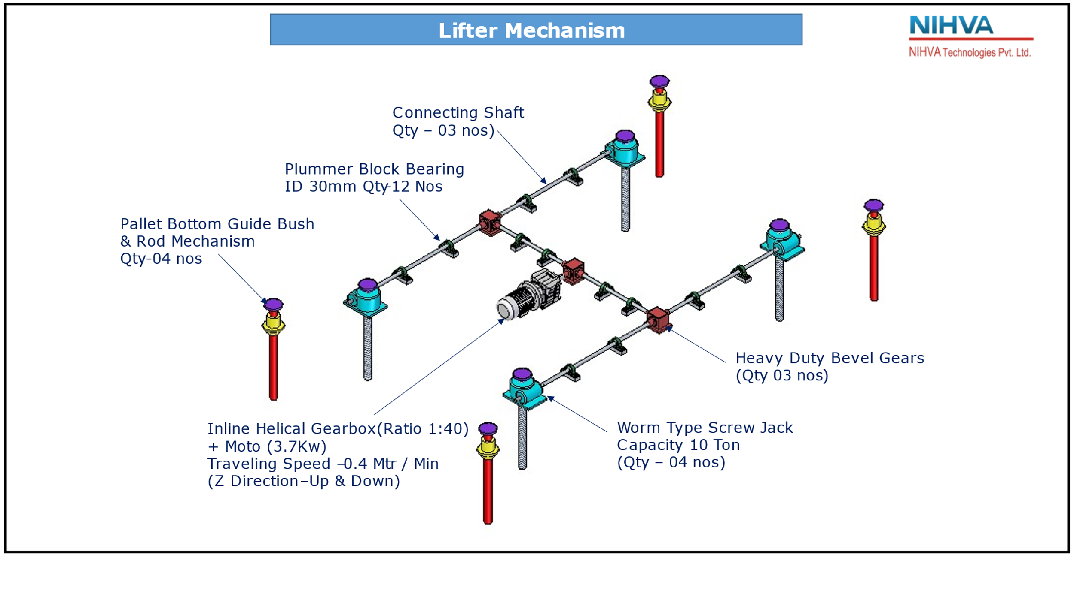
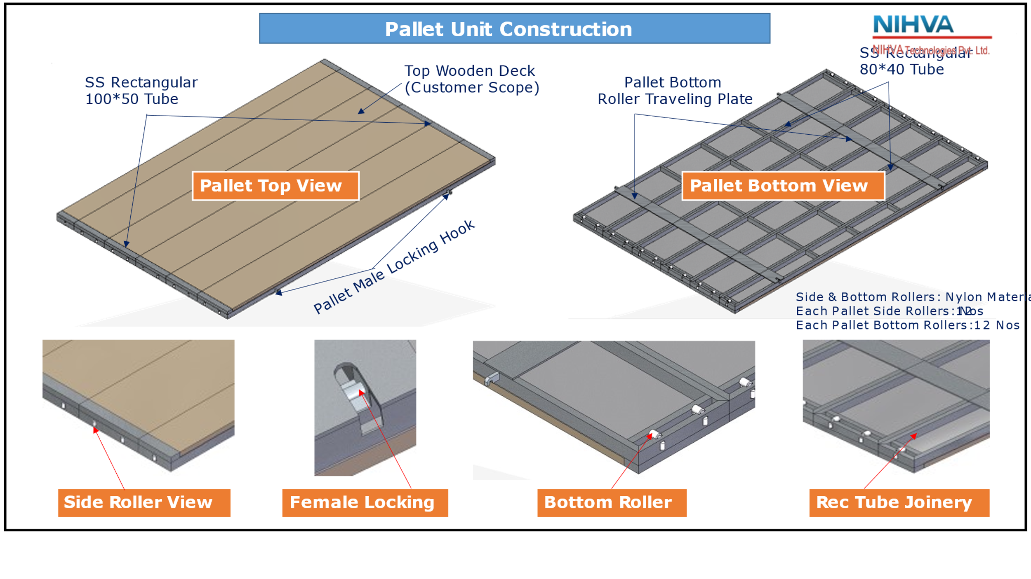

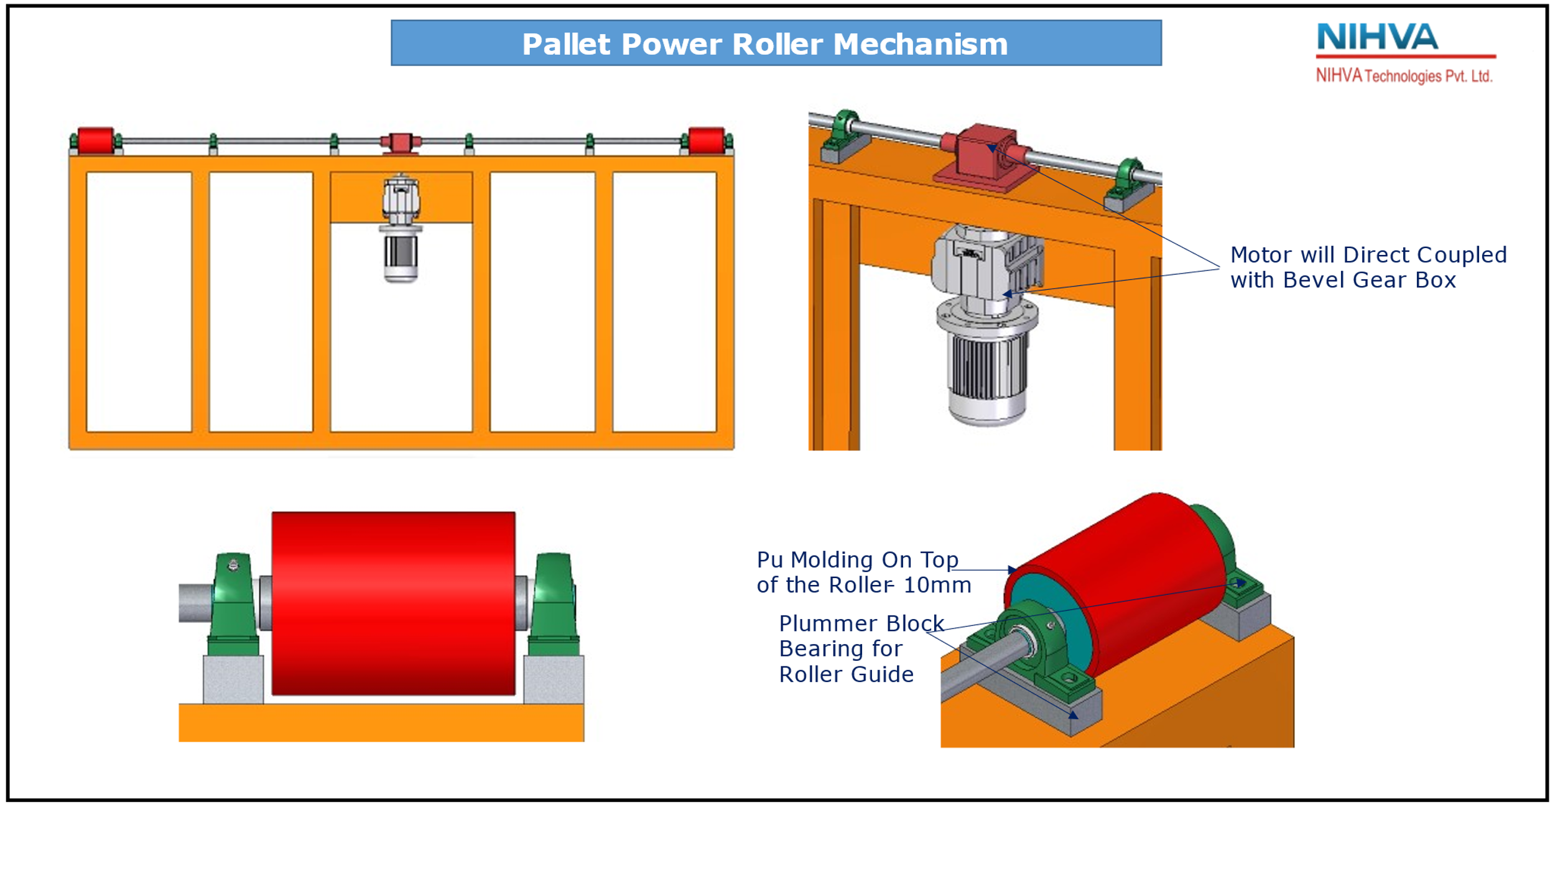
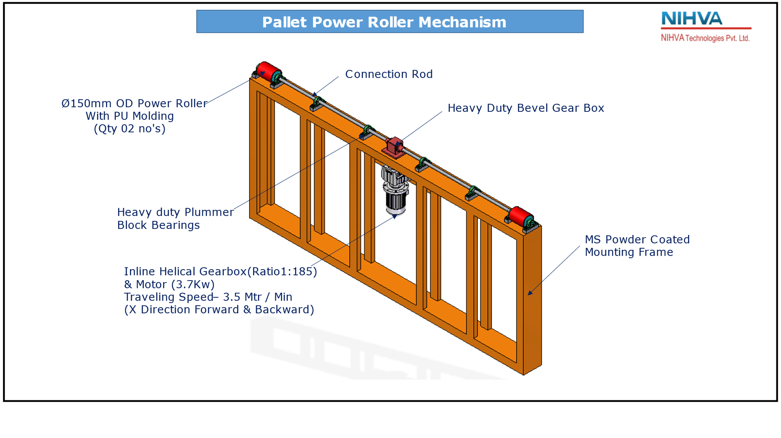

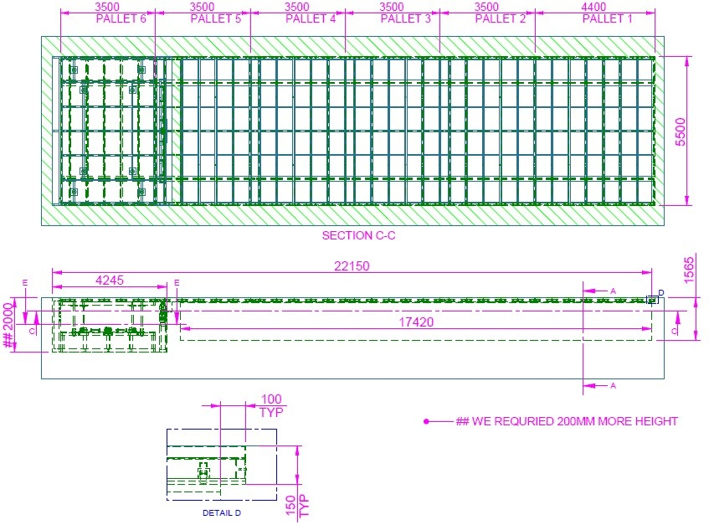
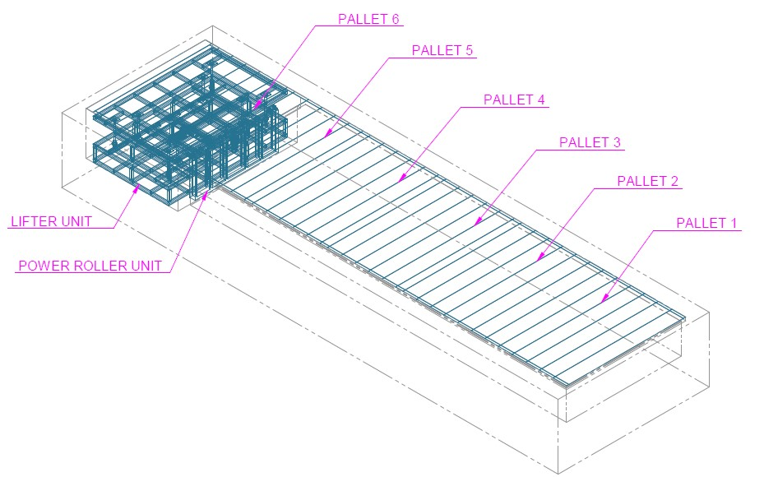
System Representation
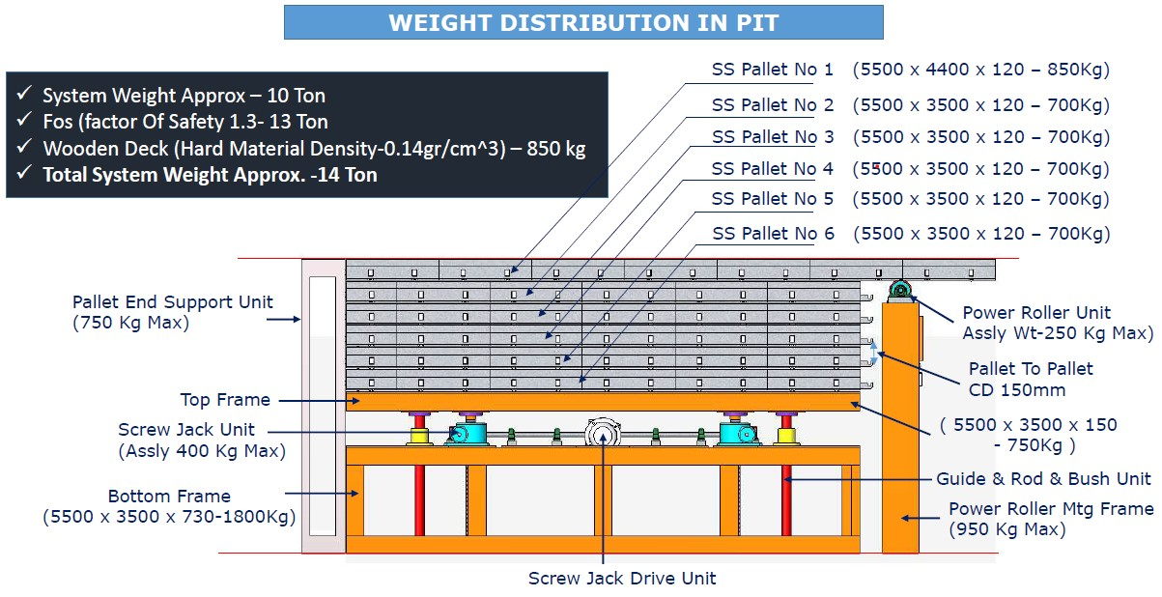
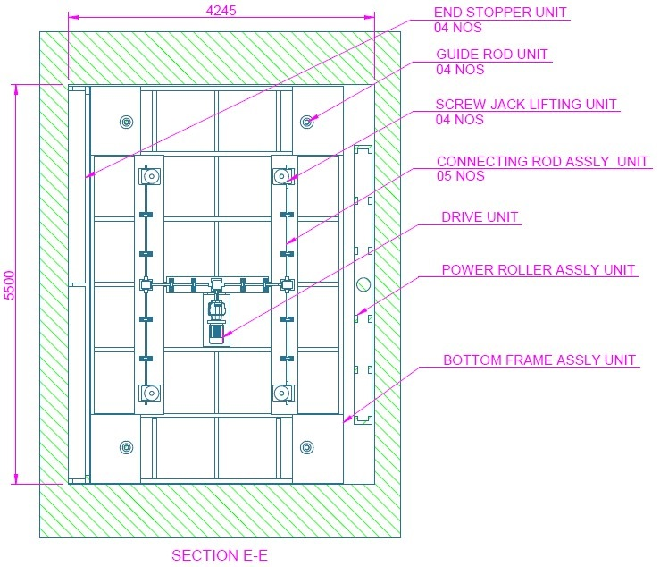
Scope of work -

- Design, Mfg, Supply, Installation and Commissioning of Sliding and Stacking deck for Swimming Pool.
- Loading & Unloading

Commercial Details -
PRODUCT | SIZE | QTY | SUPPLY PRICE | INSTALLATION PRICE | TOTAL SUPPLY & INSTALLATION
SLIDING AND STACKING DECKING FOR POOL | 5500mm(W) X 22150mm(L) | 1 | ₹ 1,55,00,000 | ₹ 5,00,000 | ₹ 1,60,00,000
P&F CHARGES | 3% |  |  |  | ₹ 4,80,000
TOTAL WITHOUT TAX |  |  |  |  | ₹ 1,64,80,000
GST | 18% |  |  |  | ₹ 29,66,400
TOTAL WITH TAX |  |  |  |  | ₹ 1,94,46,400
EXCLUDING TRANSPORTATION

Spare Parts:
DESCRIPTION | QTY | RATE | AMOUNT
PLUMMER BLOCK BEARING FOR SCREW JACK SHAFT | 5.00 | ₹10,000.00 | ₹50,000.00
PLUMMER BLOCK BEARING FOR PALLET POWER ROLLER | 5.00 | ₹15,000.00 | ₹75,000.00
PALLET SIDE GUIDE & BOTTOM ROLLERS (15+15) | 30.00 | ₹7,000.00 | ₹2,10,000.00
5HP INDUCTION BREAK MOTOR | 2.00 | ₹70,000.00 | ₹1,40,000.00
INLINE HELICAL GEAR BOXES | 2.00 | ₹1,50,000.00 | ₹3,00,000.00
BEVEL GEAR BOX | 2.00 | ₹50,000.00 | ₹1,00,000.00
WORM TYPE MOTORISED SCREW JACK 10TON CAPACITY | 2.00 | ₹1,20,000.00 | ₹2,40,000.00
 |  |  | ₹11,15,000.00

General Terms & Conditions-
  - Continuous uninterrupted access to installation section or as agreed separately.
  - Provision of 230 Volt power supply (by others) for hand tools.
  - A dry and secure area, not in direct sunlight, is to be provided for storage of the product components.
  - Access to site between 7 am to 6 pm six days per week. If this is not possible, the installation programme may require amending.
  - Any storage costs for materials due to delays outside of NIHVA, will be in Client Scope.
  - The project time indicated does not take into account adverse weather conditions that may prevent safe and efficient working practices. We reserve the right to extend the period accordingly.
  - Any passes required for the project, are the responsibility of the Customer and Contractor and must be available, before commencement of the installation. Any delays caused by the non-availability of passes, will be charged accordingly.

Sr. No | Remark
1 | Secured and fully covered Store area to keep the material | In Client Scope
2 | Scaffolding/Hydra/Crane/Forklift etc - Required for Installation at Site | In Client Scope
3 | Electrical Supply on the site single phase/three phase points at different places. | In Client Scope
4 | Any civil / masonry/structural work required | In Client Scope
5 | All structure support required | In Client Scope
6 | In Case of any changes in the layout as per site requirements after the shipment of material, the additional quantities and the wastage. | In Client Scope
7 | Conduits, Cables required | In Client Scope

Terms & Conditions-

Price: Ex Works Pune
Delivery: Approximately 12 weeks from having received official order confirmation + advance payment + signed & stamp drawing approval
(subject to - Lead time might be impacted due to current crisis of Covid -19)
Payment: 70% Advance along with confirmed Purchase order
15% along with approval of drawings and before start of production.
10% before dispatch from origin
05% against completion of Installation, Testing and Commissioning.
Validity: Validity of Offer is 15 days from the date of quotation.
Warranty: from date of supply -
5 Years for manufacturing defect on the structural system.
3 Years for mechanical and drive system.
2 Years for all electrical system.
Compensation Please note that in the event the buyer cancels an order, after the
Clause : order is confirmed to us, it is binding to the buyer to pay NIHVA a
compensation of 25% of order value.

Please feel free to Contact us for any further Clarification Information in this Concern.

With Best Regards,
Gaurav Jain
+91-9680117657e
Nihva Technologies Pvt. Ltd.

